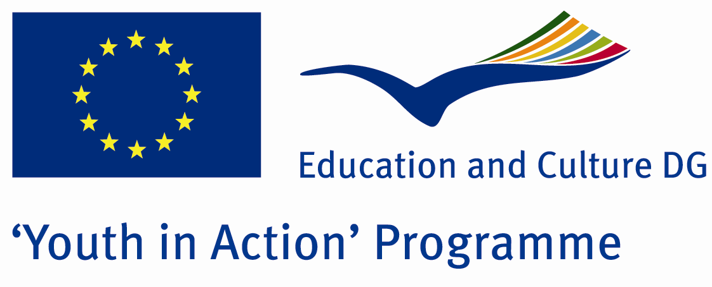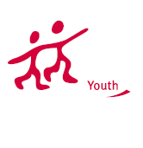

We won’t be Destroyed

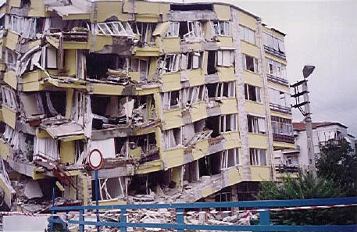

ACTION 4.3 – TRAINING AND NETWORKING

20-26th August, 2011

Kilis, TURKEY

ACTION 4.3 – TRAINING AND NETWORKING
20-26th August, 2011
Kilis, TURKEY

Please contact directly to;
adventurerpeacepigeons@gmail.com

Project Summary;

Earthquake is a natural disaster. What time, where they will be is not clear. Measure not taken a real serious consequences. Impossible to avoid, but not impossible to protect against earthquake. Earthquake as a country have paid a heavy price. After that we wrote this project to discuss what can we do?We are making preparation for a major earthquake. Do you contribute to us on this issue?

Project Title; We won’t be Destroyed

Date and Venue ; 20-26th August, 2011 Kilis, Turkey.

Target Group ; Municipalities, City Councils and Non-Governmental organizations,
youth groups,culture and art groups,e.t.c

Participants ; 5 people from each country (over 18 -25 ). Totally 8 countries.

Conditions ; Accommodation, board and programme costs will be financed through European Commission Youth in Action Programme (Action 1.1). Travel costs will be reimbursed in 70% (APEX Tarrifs). Organizations from all 27 EU member countries plus Liechtenstein , Norway and Iceland are eligible to take part.

Working language: English

Organizer; Discovery And Adventure Group

How to apply: If you are interested, please send your Part III forms to
0090 216 494 39 98 by FAX please. (Fulfilled Part III which you can find in the attachment, of course signed and stamped) ..

Note: jpeg is not allowed..please send by fax…

Next step 2;
Original send via regular post to this address please:

Ertan DERİN
Öner İnşaat
Abdulhalik Renda Cd.
Parlar Sk. No:4 Pendik/İSTANBUL

If you have any questions you may contact with: adventurerpeacepigeons@gmail.com

Deadline for application; until 20 March 2011.

For Further information:
Contact Person
Ertan DERİN
Öner İnşaat
Abdulhalik Renda Cd.
Parlar Sk. No:4 Pendik/İSTANBUL

e-mail : adventurerpeacepigeons@gmail.com
Mobile : 0090 542 393 93 90
Fax : 0090 216 494 39 98

